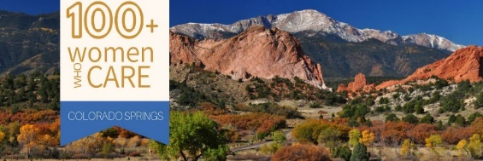

PRESENTATION TALKING POINTS
- Your name_______________________________________________________
- Name of organization and how long they have been operating. Are they a 501(c)(3)?

______________________________________________________________________________

- Is the organization listed on Candid- formerly Guidestar? __________________________

- Organizations’ mission statement:
_______________________________________________________________________________________________________________________________________________________________________________________________________________________

- Is the organizations service area Colorado Springs and El Paso County? ____________________

- What segment of our population do they serve? _____________________________________________________________________________________________________________________________________________________________________________________________________________________

- Specifically, what does this organization do, and how do their services benefit our community?

__________________________________________________________________________________________________________________________________________________________________________________________________________________________________________

- Organizations finances: Size of their operating budget? _________________ How much do they spend on administration and fundraising? ___________________________________

- What is their primary source of funding? ____________________________________________

- How would our funds be used? _______________________________________

- Is there a specific need you are requesting funds for? _________________________________

- Is this nonprofit a subsidiary of a larger organization? ________________________________

- To whom would out funds be made payable? _________________________________________

Please share your personal connection or a story of how the organization helped someone.

100WWCCS.com

